FIND ME NOW
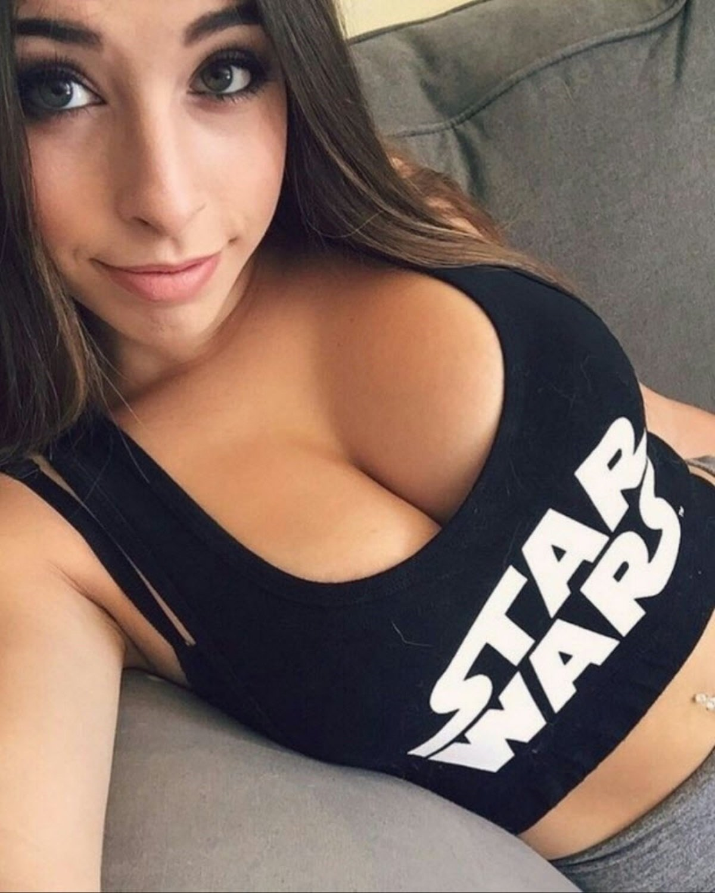
Unsubscribe https://violittenos.work/uns/

