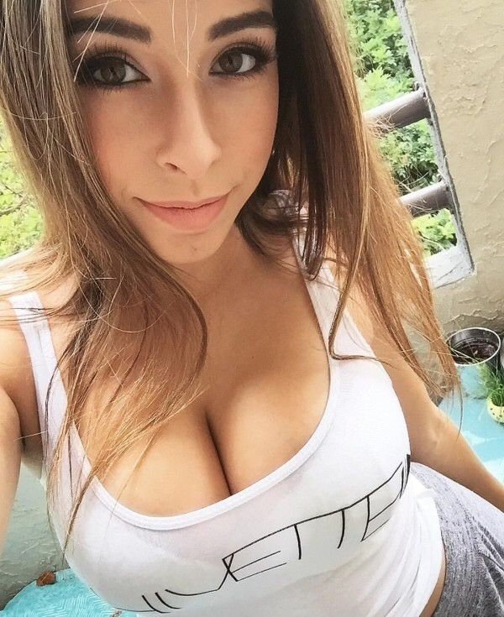
FIND ME HERE

unsubscribe

