SEE MY PAGE
@Kira726311
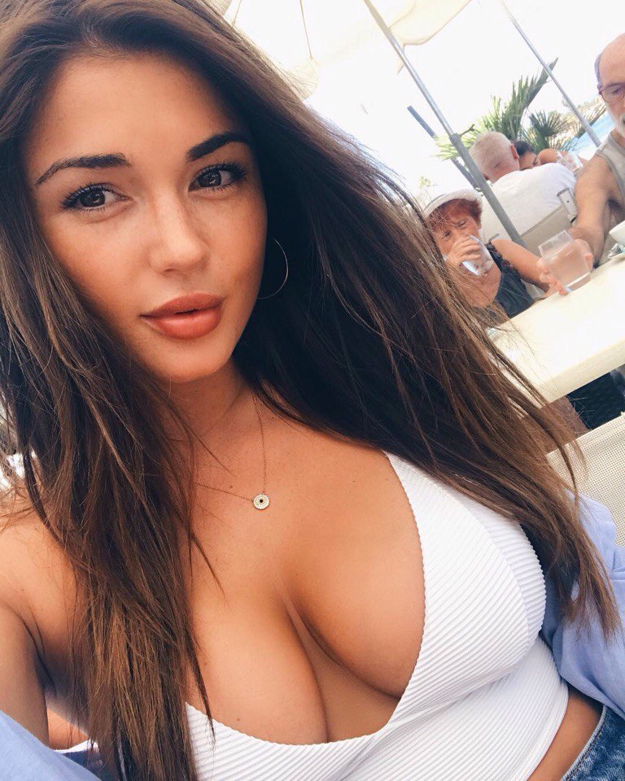
unsubscribe->

