Here Is Your Fortune
Beauty Wanna Chat to You
Check my page id: 85gE7172583acdf

CHECK NOW
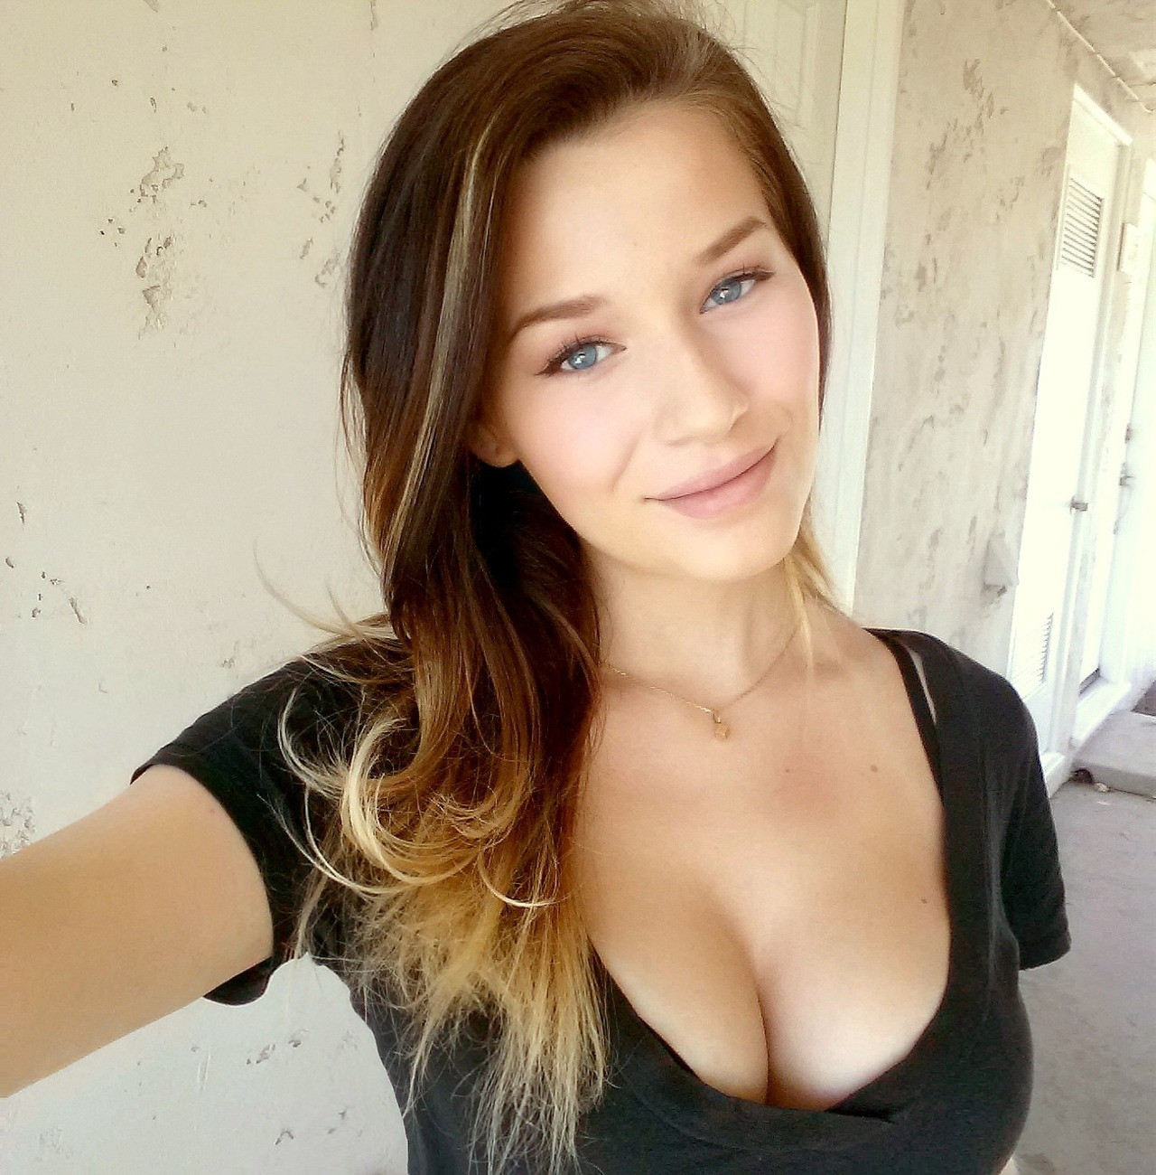
uns here

