You're Lucky My Friend!
Best Babes Only Here!
Look at them HERE
Here is my Nick: loretta8928395

VIEW PAGE
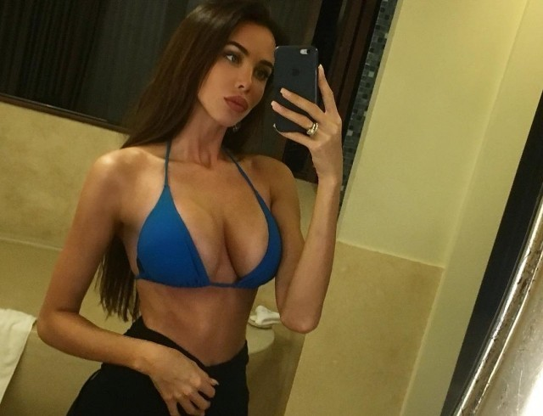
u-n-s-ubscribe

