UNBELIEVABLE BEAUTIFUL GIRLS
I WANNA SHOW YOU MY BODY
Chat To Me NOW!
TRY NOW - jiji4249161

VIEW NOW
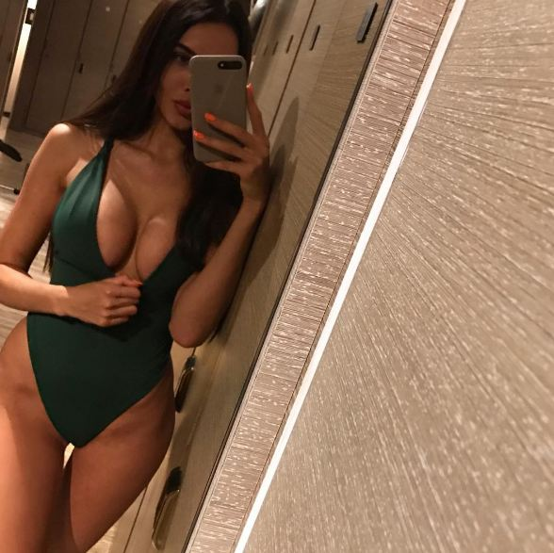
uns here

